**44-599: Introduction to Data Visualization**

**Individual Tool Presentation**

**Objective:** The main objective of this worksheet is to generate **Tree map and Shape map** using **Microsoft Power BI**.

**Worksheet for drawing Tree Map using Microsoft Power BI (desktop version) tool**

1. Dataset



1. Data Source: <https://www.eia.gov/electricity/data/state/sales_annual.xls>
2. Open <https://powerbi.microsoft.com> from the product menu select Power BI Desktop then new page will be opened, click on the download button and install the Power BI Desktop version.
3. Open Power BI Desktop tool click on the get data from menu and select excel sheet and load the sheet1 from the loaded data.
4. Select Tree map from visualization and Drag the data fields into the groups and values as shown below:

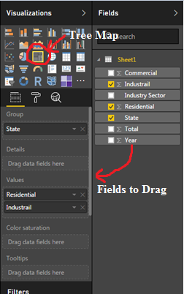

1. Then the chart is obtained as below: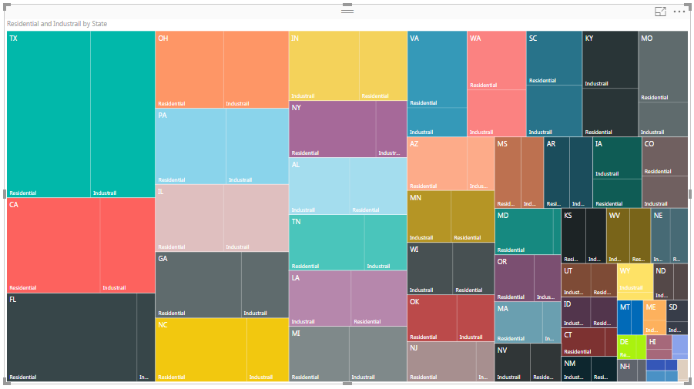

**Worksheet for drawing Shape Map using Microsoft Power BI (desktop version) tool**

1. Dataset



1. Data Source: <https://www.eia.gov/electricity/data/state/sales_annual.xls>
2. Open <https://powerbi.microsoft.com> from the product menu select Power BI Desktop then new page will be opened, click on the download button and install the Power BI Desktop version.
3. Open Power BI Desktop tool click on the get data from menu and select excel sheet and load the sheet1 from the loaded data.
4. The **Shape Map** visual is in Preview, and must be enabled in Power BI Desktop. To enabled **Shape Map**, select **File > Options and Settings > Options > Preview Features**, then select the **Shape Map** checkbox. You'll need to restart Power BI Desktop after you make the selection. 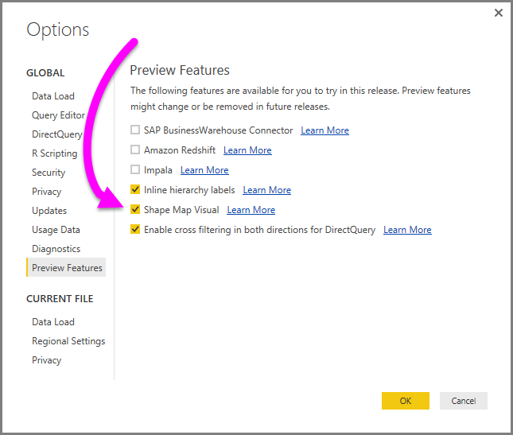
5. Once **Shape Map** is enabled, click the **Shape Map** control from the **Visualizations** pane.

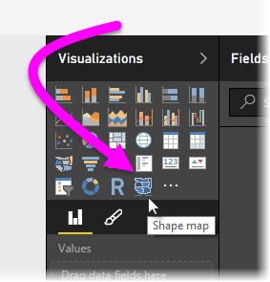

1. Power BI Desktop creates an empty **Shape Map** visual design canvas.

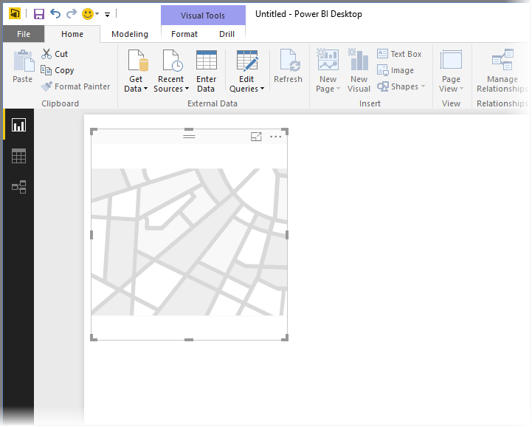

1. In the **Fields** pane, drag a data field that has the region names onto the **Location** bucket, and a data measure field into the **Color Saturation Values**bucket**.**

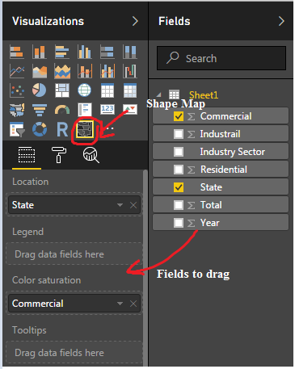

1. Then the chart is obtained as below: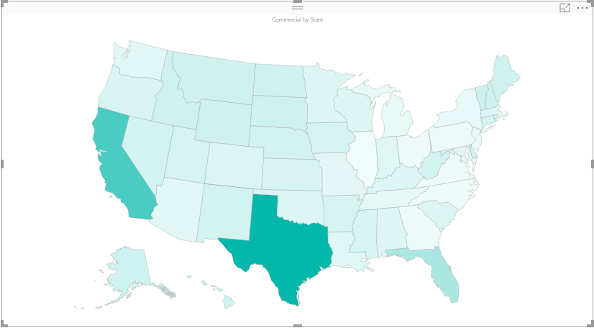
2. In the **Format** settings pane, expand **Shape**, and select from the **Standard Maps** drop-down to show your data. At this point the rendering appears, as shown in the following image.

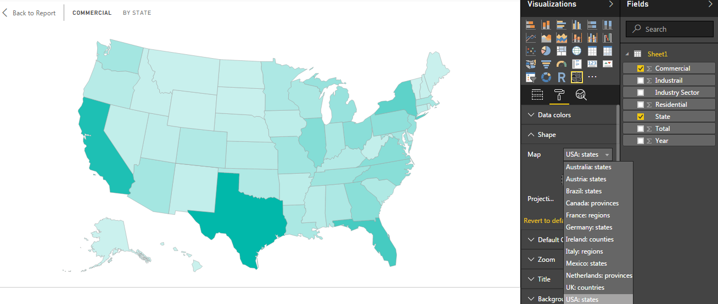

1. You can also add a category data column to the **Legend** bucket, and classify the map regions based on categories.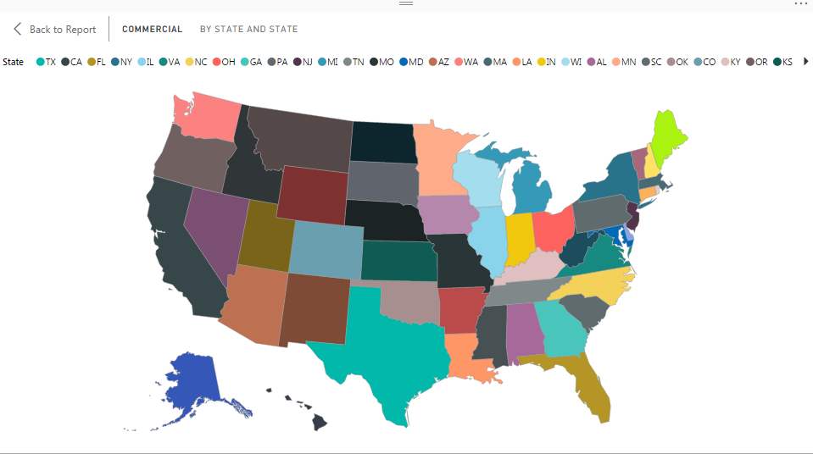

**GitHub Link:** https://github.com/RajasekharS7/Siravati_Microsoft-Power-BI